- UK CPI inflation remains on track to return to the Bank of England's 2% target in April. Further sharp falls in wholesale gas prices should push the energy price cap down in July and keep inflation below 2% throughout H2 2024.
- Still, the stickiness of pay growth will keep services inflation elevated. As the downward pressure from falling energy prices and other non-core categories gradually fades, we forecast headline inflation to rebound slightly above target next year.
- We expect the Monetary Policy Committee will conclude that core inflation and pay growth have cooled sufficiently to start cutting Bank Rate in June. But the likelihood that core pressures remain firm is consistent with our view that the MPC is likely to adopt a relatively cautious approach to the pace of rate cuts.
The UK inflation outlook was transformed by steep falls in oil and wholesale gas prices at the end of 2023, which led us to forecast that CPI inflation would return to the Bank of England's 2% target in April. Recent data have supported this view. Indeed, there is now a good chance that inflation will continue to fall and spend a period below target.
Further declines in wholesale gas prices mean the energy component should continue to drag heavily on headline inflation throughout 2024. Meanwhile, the food and core categories will benefit from strong base effects and the indirect effects of lower energy costs. Therefore, our latest forecast shows inflation dropping well below 2% in H2 2024.
However, the downward pressure from falling energy prices will likely prove temporary. We expect this impact will fade next year and, with services inflation likely to remain elevated, inflation is forecast to rise slightly above the BoE's 2% target in 2025 (Chart 1).
Chart 1: CPI inflation is forecast to fall below the BoE's 2% target for much of 2024
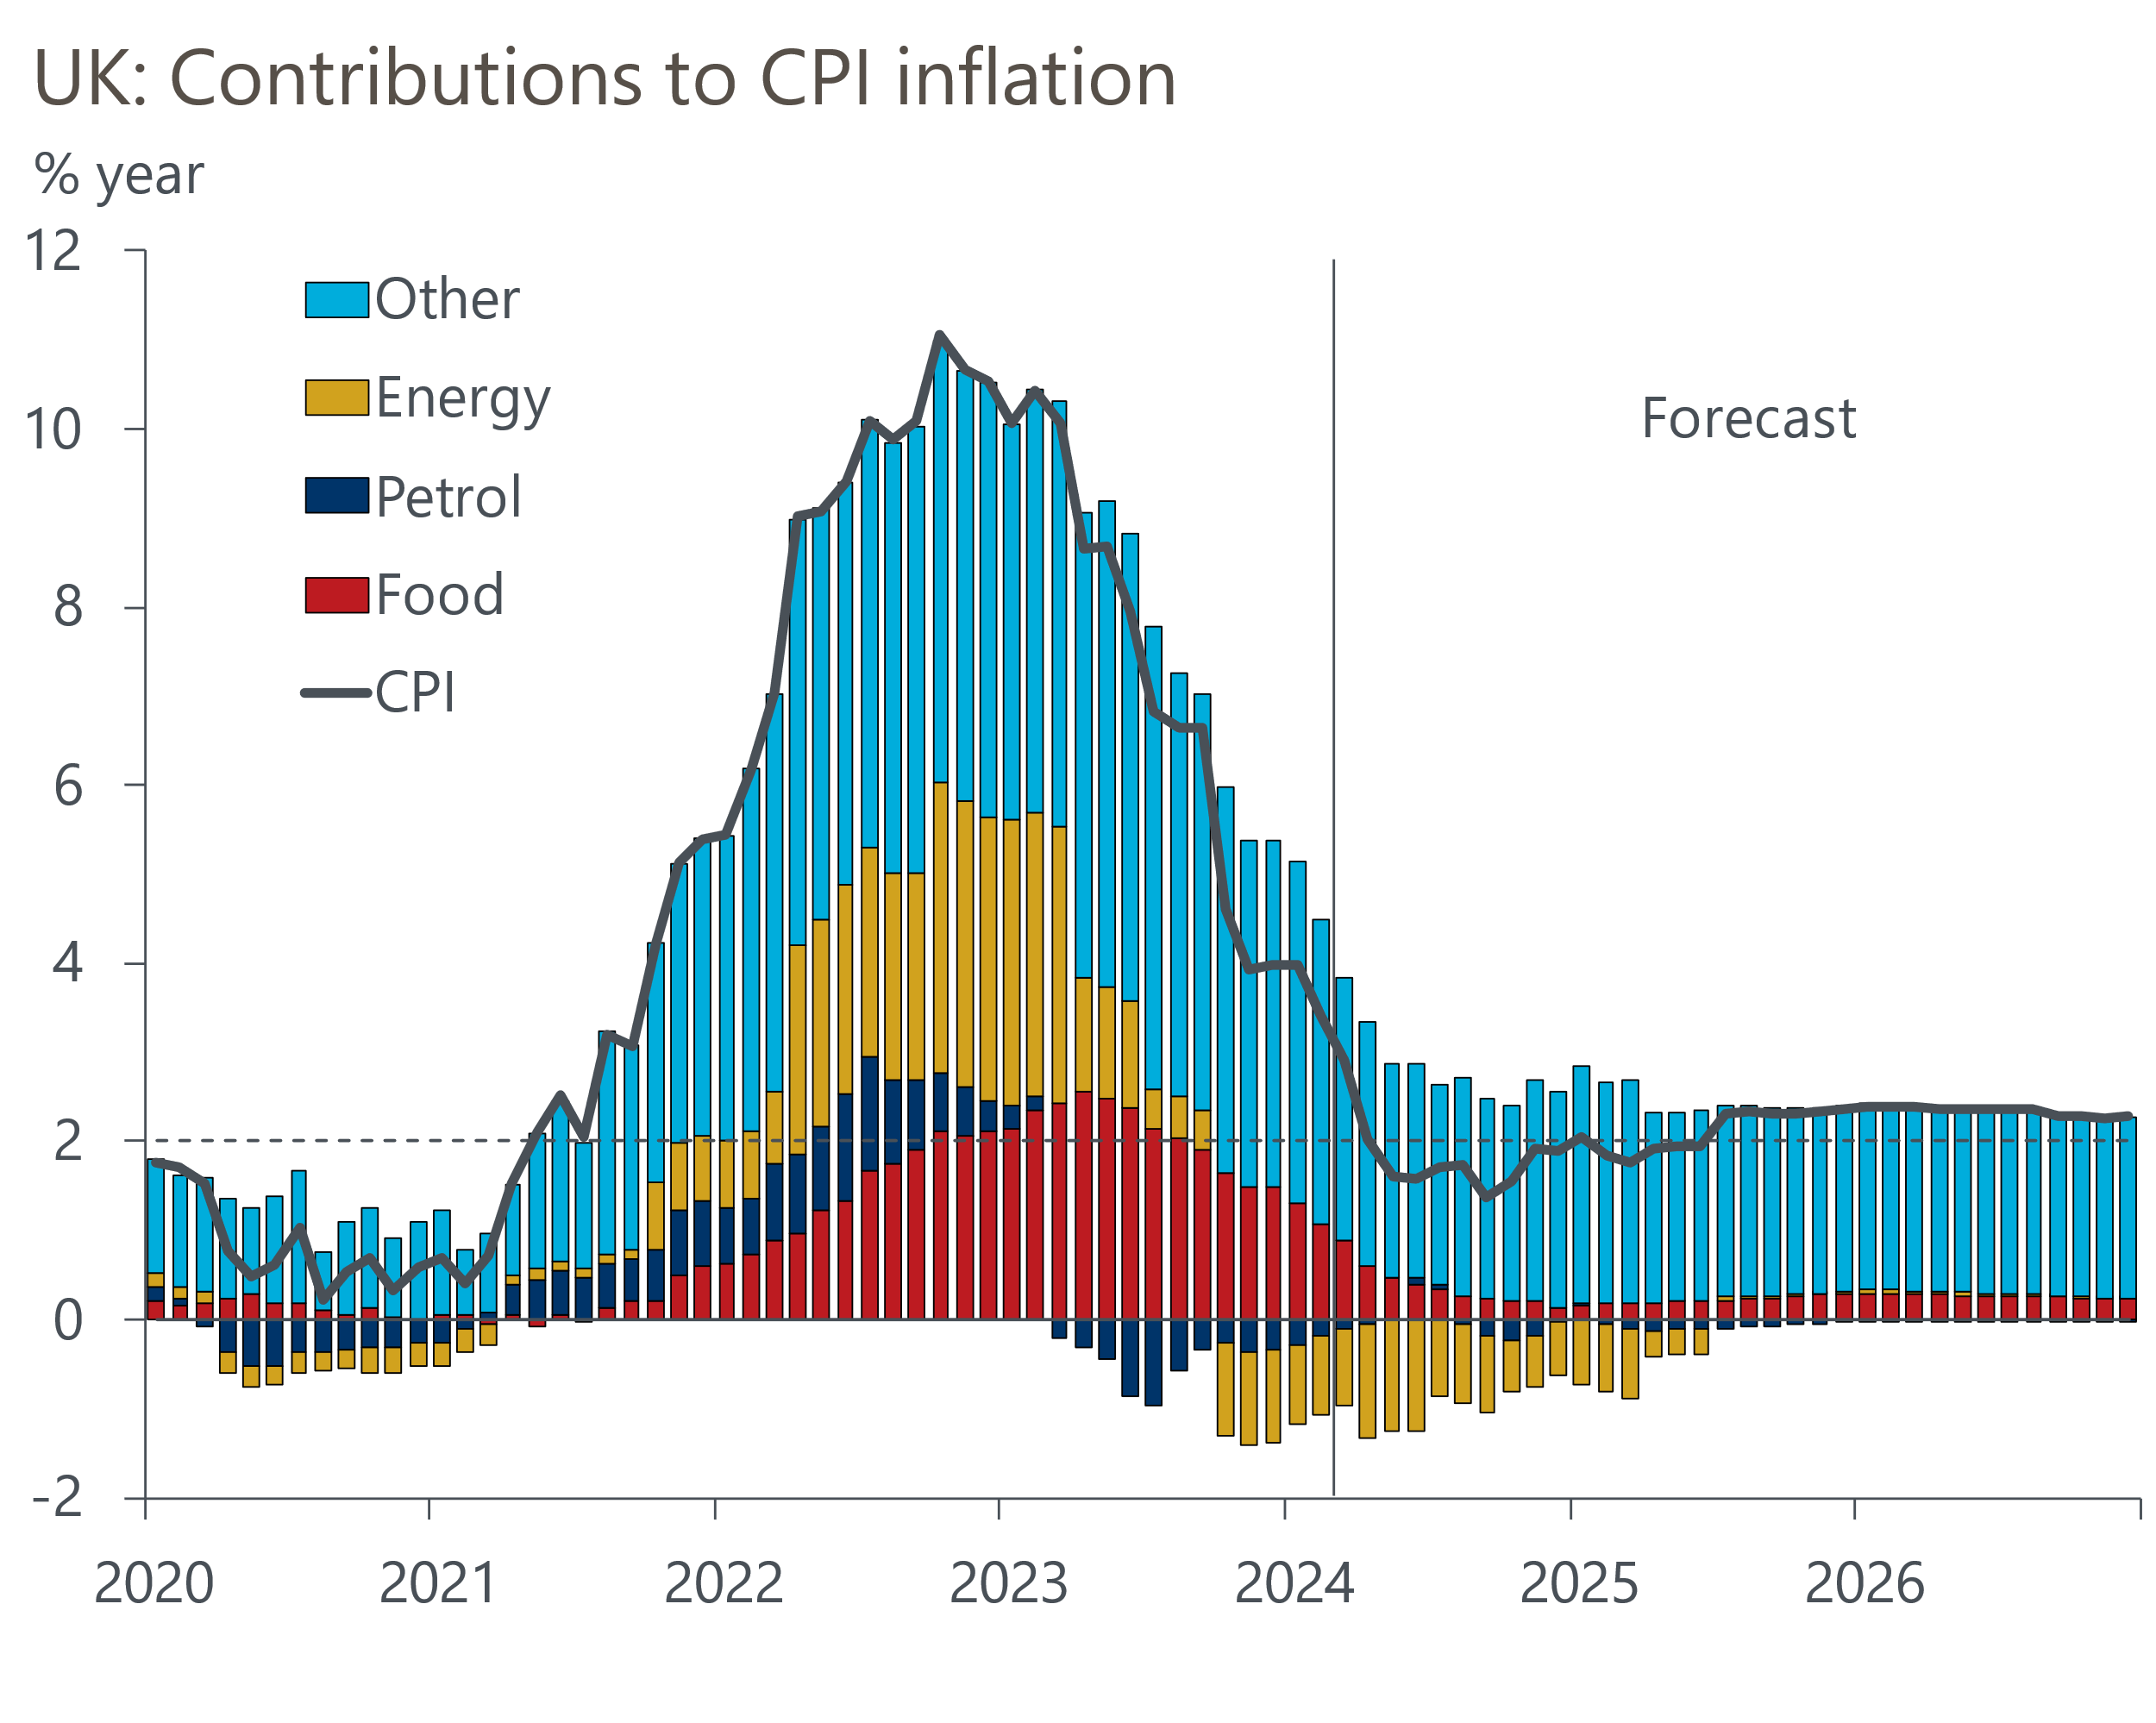
Source: Oxford Economics, Haver Analytics

Successive declines in the Ofgem price cap will drag on consumer prices
Though wholesale gas futures prices have stabilised in recent weeks, supply- and demand-side factors have contributed to significant downward pressure on prices since October 2023. The second consecutive warmer-than-usual winter, efficiency gains, and a degree of industrial demand destruction in continental Europe, has weighed on gas consumption. Meanwhile, most of the loss of Russian pipeline supplies has been compensated for by other sources, mainly American liquefied natural gas. This has left European gas storage at record levels. Our commodities team expects gas prices will remain low over the rest of this year as a near term pickup in European industrial demand is likely to be offset by savings among households and the power sector, while long-term LNG contracts will support gas supply.
The large fall in wholesale gas futures prices is good news for UK households. Falling wholesale prices around the turn of the year led Ofgem to cut its energy price cap by 12% in April. We are now halfway through the new observation window, and a further decline in futures prices mean we are on track for another 8%-10% fall in the price cap in July (Chart 2). Our forecast shows the energy category exerting an average drag on CPI inflation of 0.9ppts in 2024. Given that household energy prices began to fall in H2 2023, the energy category is likely to weigh on headline inflation most heavily in H1 2024, before the downward pressure from energy gradually fades.
Chart 2: The fallback in gas futures prices will weigh on energy inflation in April and July
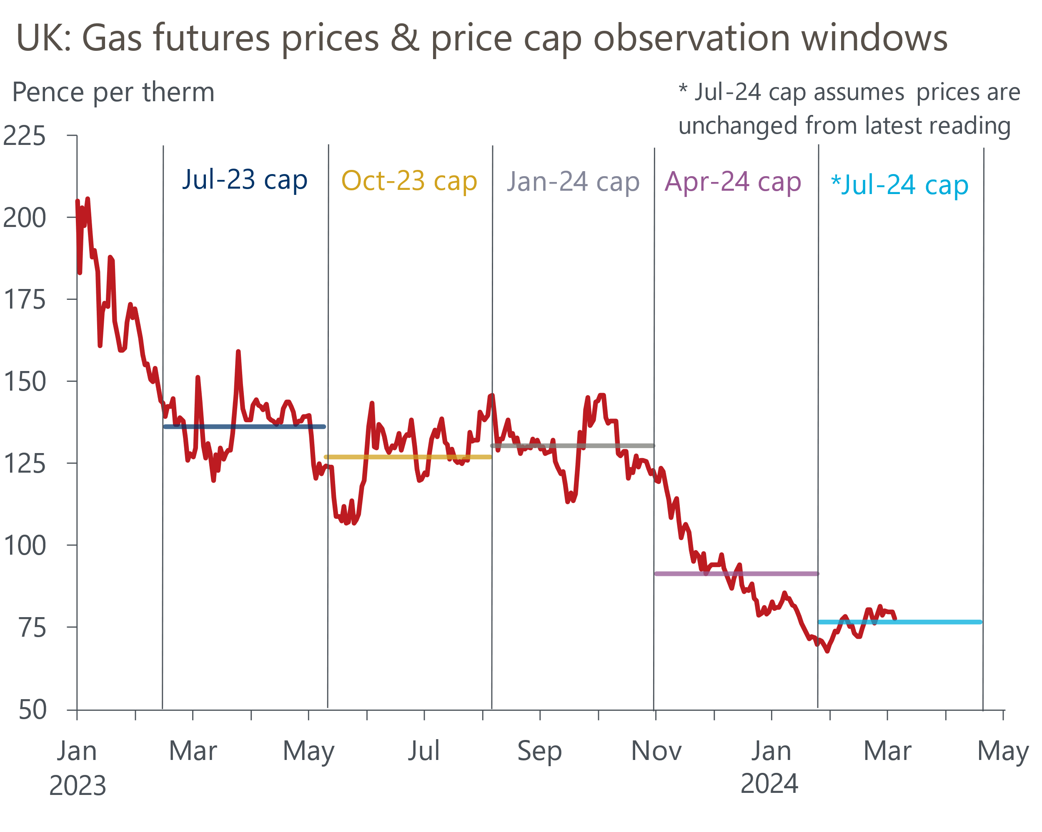
Source: Oxford Economics, Haver Analytics

Global food prices and domestic cost pressures indicate food price inflation will weaken
Another key externally driven component likely to drive headline inflation below 2% in the coming months is food. The combination of high energy prices and poor harvests in Southern Europe, which caused shortages of certain products, led to a series of large m/m food price increases in early 2023 (Chart 3). Although food is a relatively energy-intensive sector, so it will benefit disproportionately from falling energy prices for firms. With prospects looking better for harvests this year, and significant base effects coming into play, we see the positive contribution from the food category gradually diminishing as we move through the year.
Chart 3: The large m/m food price rises seen in H1 2023 are unlikely to be repeated this year
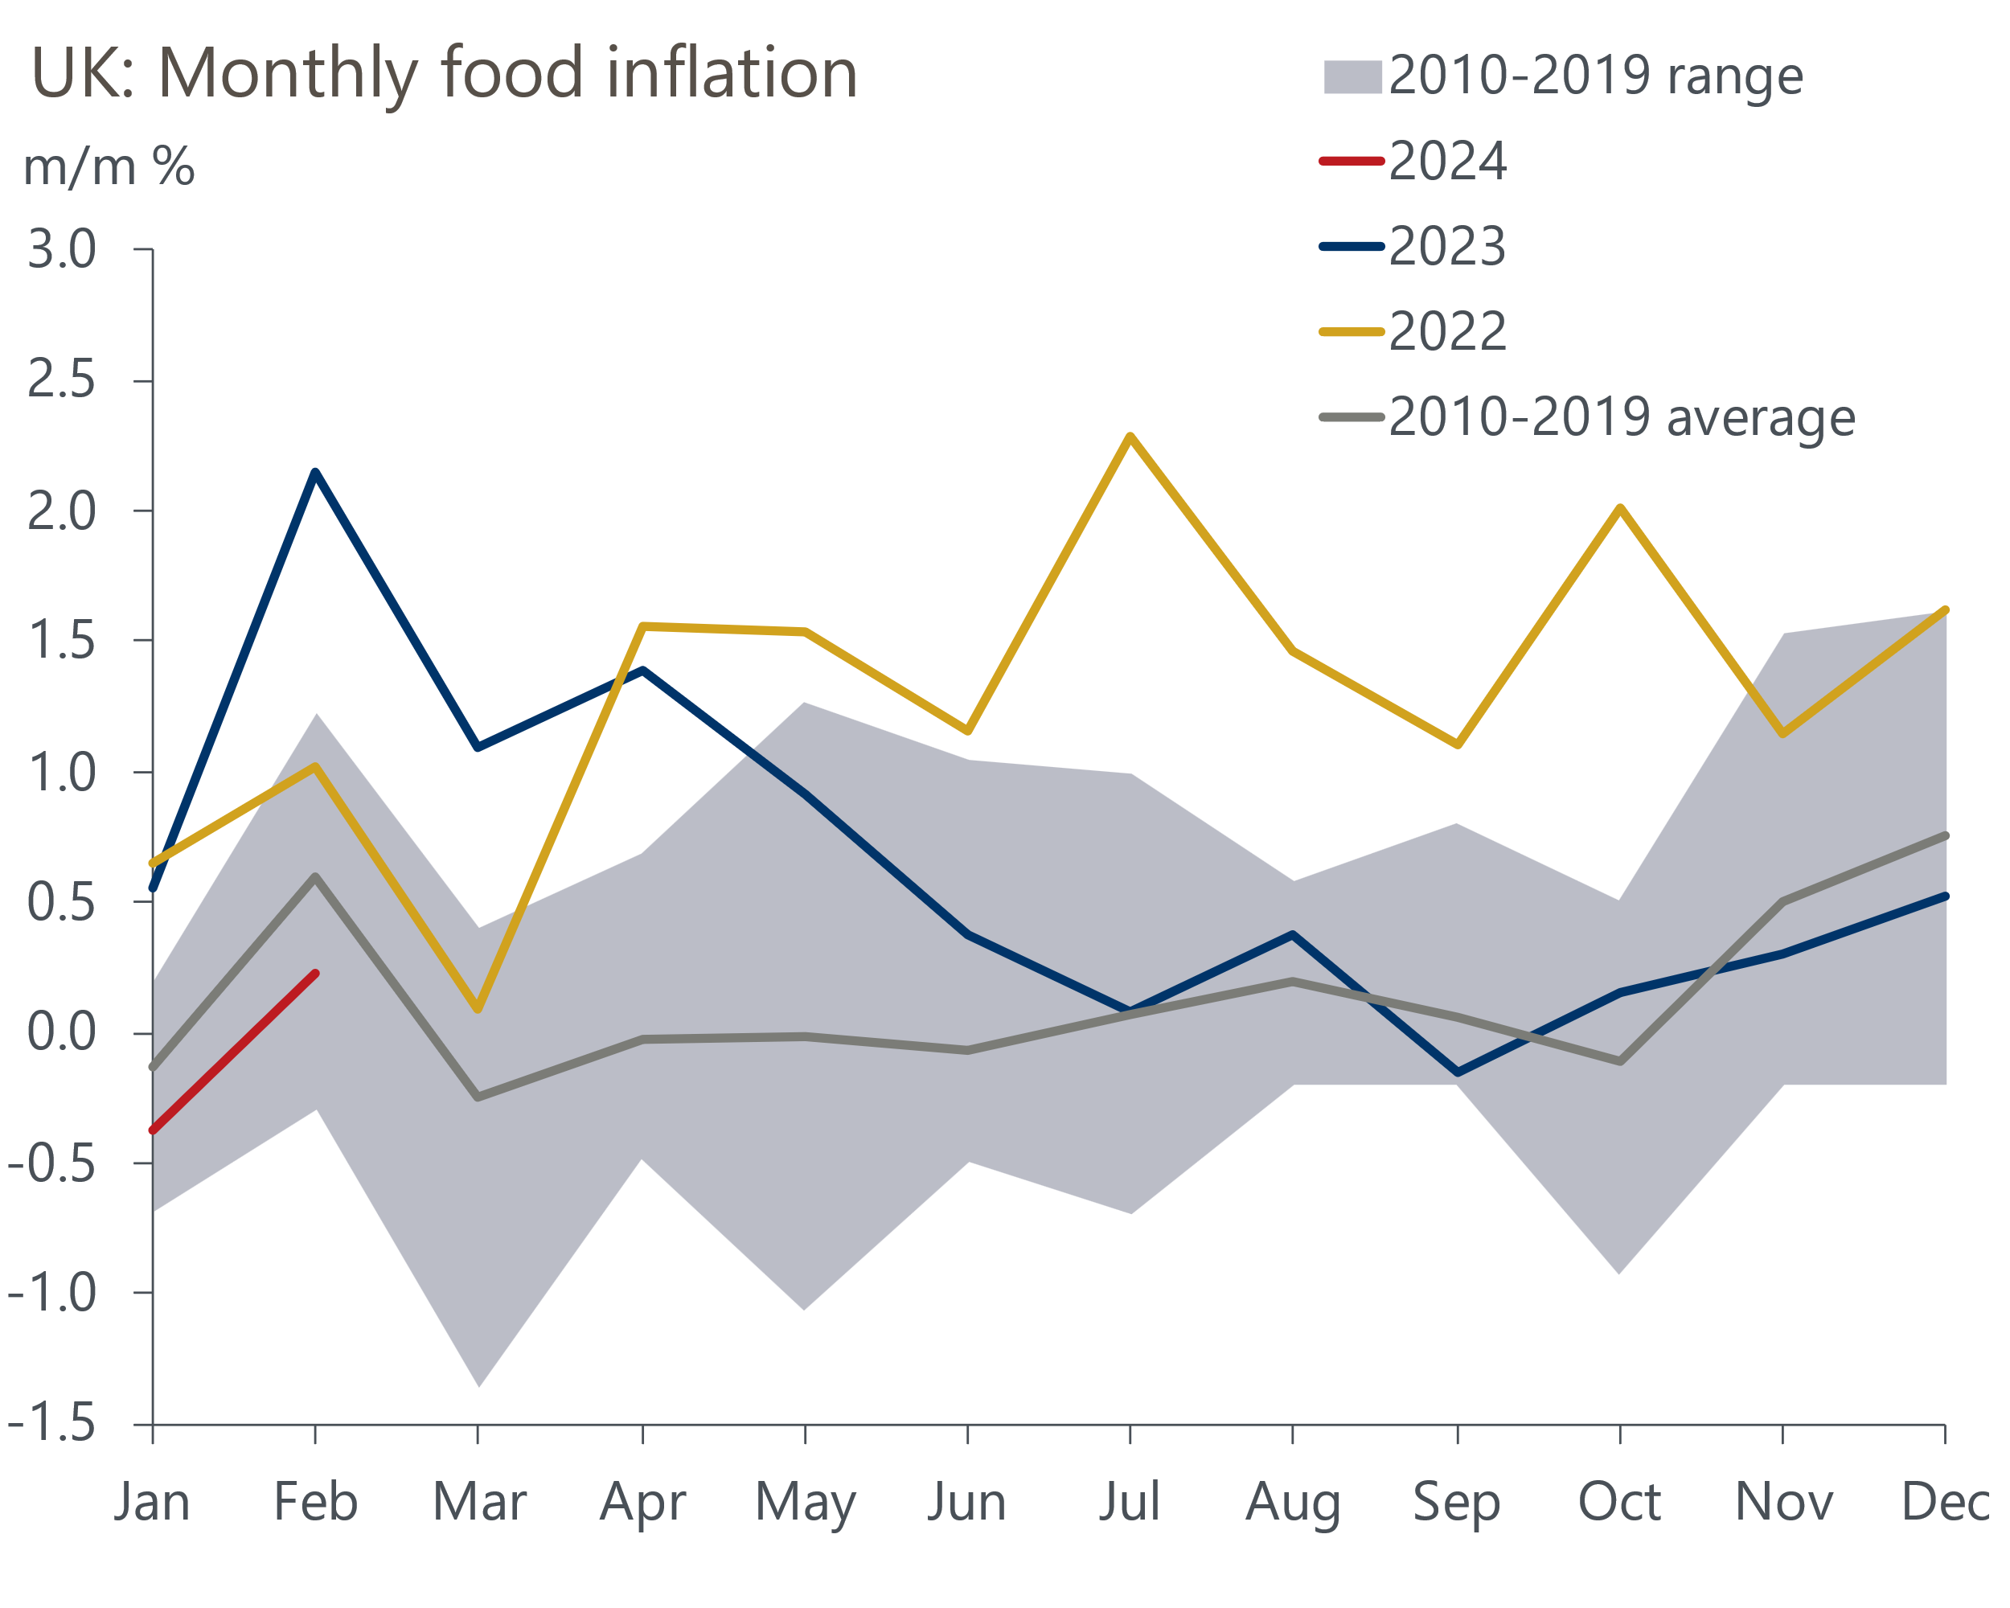
Source: Oxford Economics, Haver Analytics

Core inflation is set to slow, but the positive contribution from services will remain large
We think there will be three key factors behind the gradual cooling in services inflation this year. First, is that lower headline inflation should mean that April's annual indexation of inflation-linked contracts and regulated prices results in much softer April price hikes than the large increase experienced in 2023.
Second is that the indirect effects of lower energy prices will continue to filter through to services firms. Company energy prices often respond to changes in wholesale prices with a significant delay because a large proportion of firms agree to fixed-price contracts for up to a year in advance. As these fixes end and firms move onto cheaper deals, they are likely to pass on some of the gains to consumers.
Third is the evolution of the jobs market. Labour is the main input cost for service providers, so plays a crucial role in price setting in the sector. Pay growth is elevated but slowing as inflation expectations moderate and labour demand weakens. Indeed, our proprietary sentiment-based wage nowcast, developed in collaboration with Penta, suggests the downward momentum in pay growth gathered pace in March and the first half of April (Chart 4).
Chart 4: Our wage indicator suggests pay growth is now cooling sharply after levelling off in early 2024
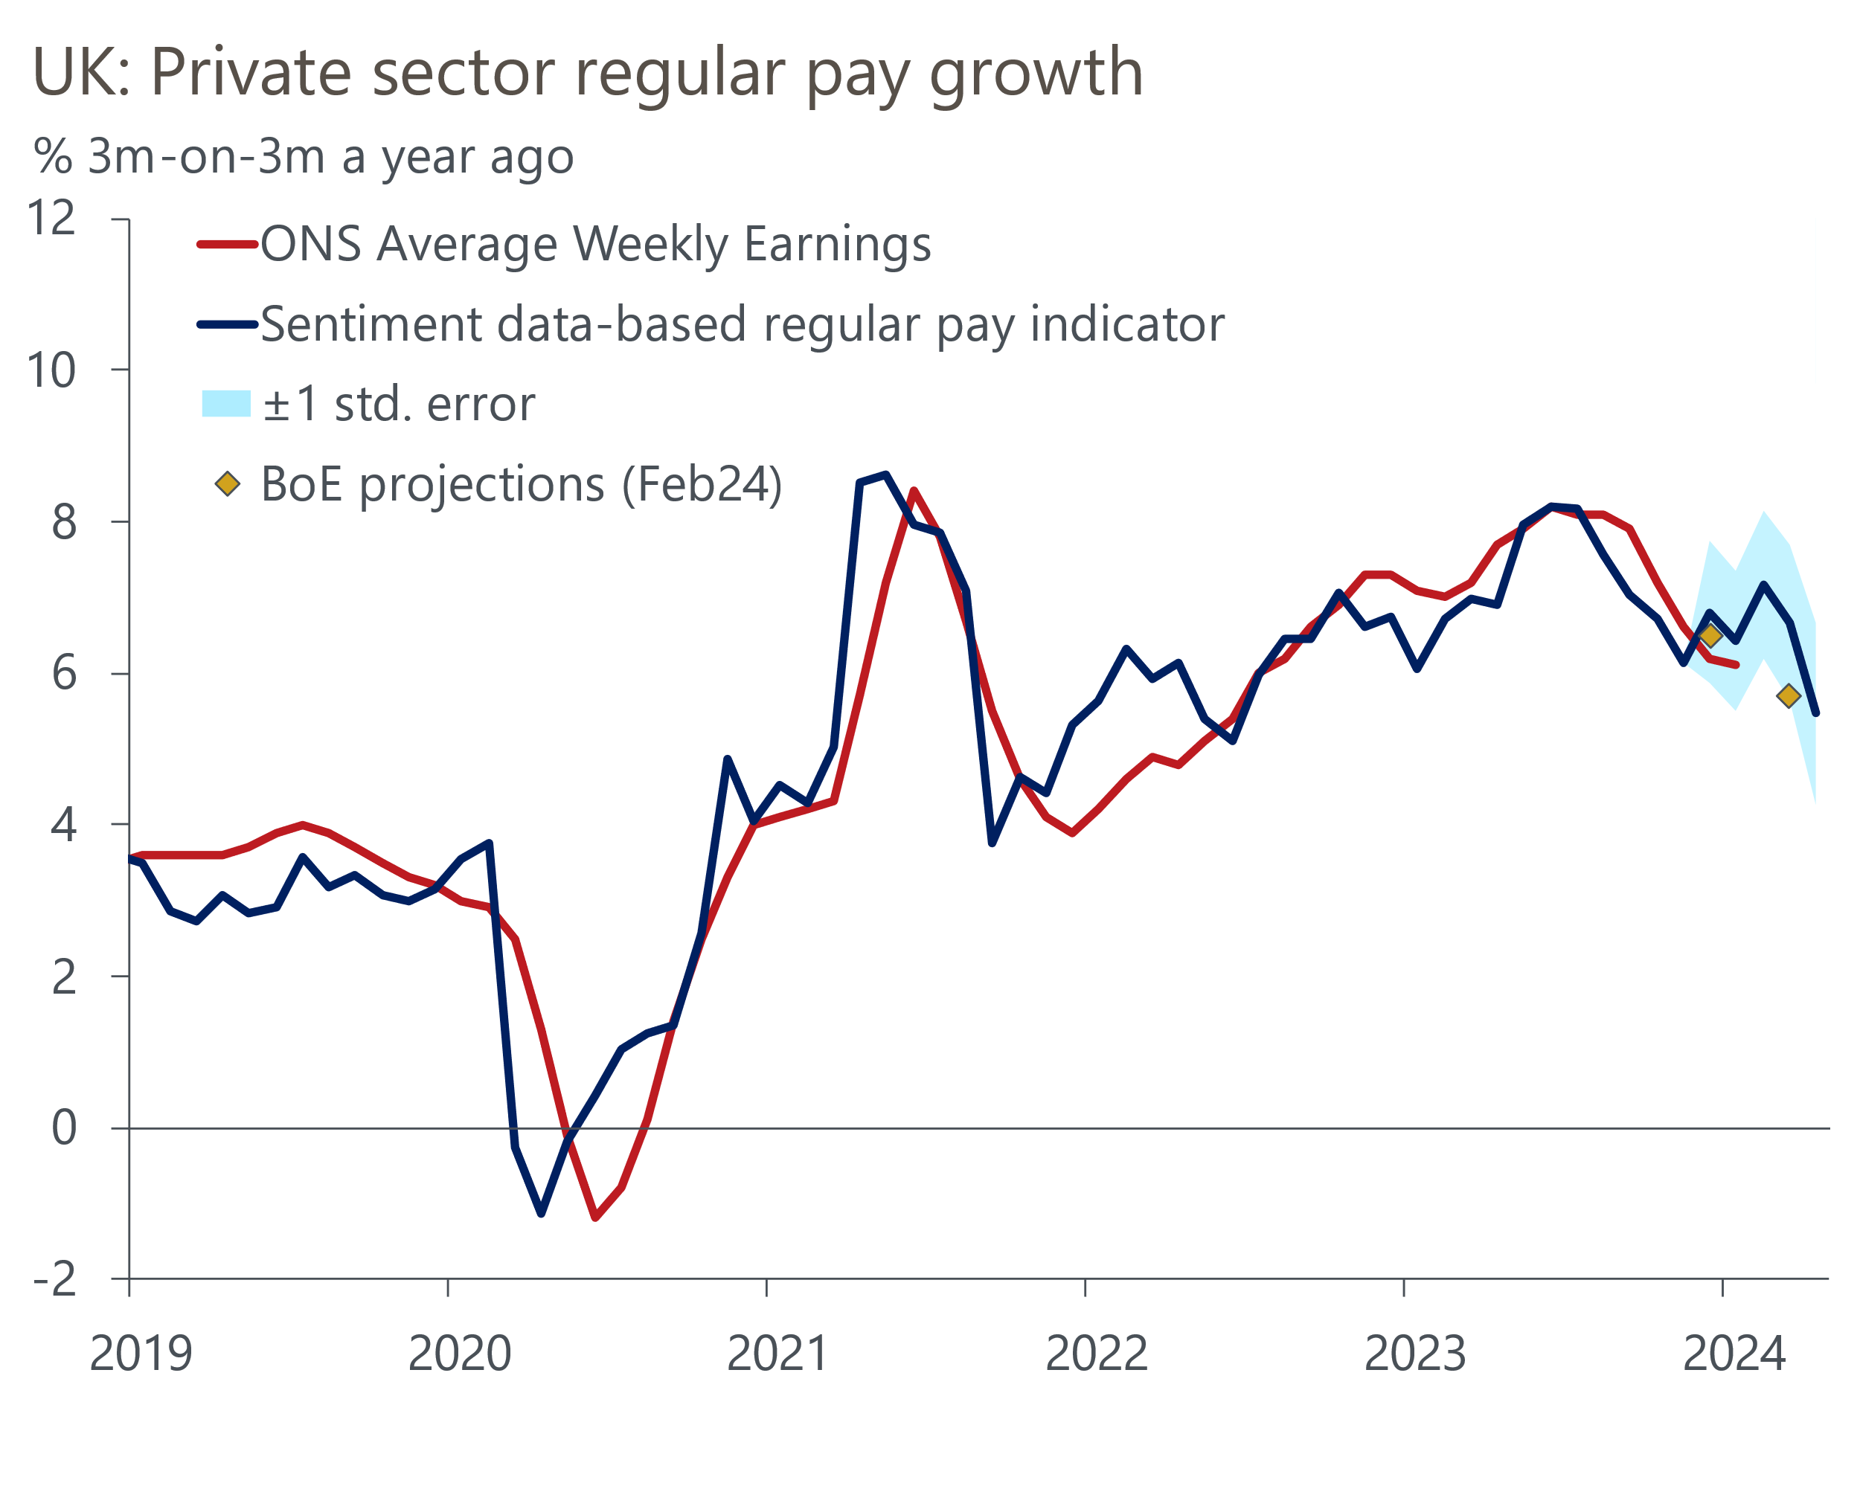
Sources: Oxford Economics, Penta, Haver Analytics
We expect the softening in pay growth and labour demand will continue to play out over the rest of this year. Still, pay growth remains relatively high and April's near-10% increase in the National Living Wage could have a direct and indirect impact on pay, by causing a 'ripple effect' in pushing up pay rates just above the new NLW level. This is likely to mean that pay growth and services inflation cools only gradually.
In comparison, price pressures look more sanguine in the core goods category. The past upward pressure on core goods prices, reflecting supply-chain disruption and strong demand during the pandemic, has almost entirely unwound now. Producer input prices are still falling, so we think there is scope for a softening in core CPI goods prices. That said, the ongoing disruption to shipping in the Red Sea is likely to slow the pace of decline in the core goods category. With around a quarter of UK goods imports coming from Asia, we expect higher ocean freight costs to add 0.2ppts-0.3ppts to headline inflation over the rest of this year.

Higher inflation in 2025 suggests the BoE will loosen policy cautiously
After inflation has returned to the 2% target, we see it falling further in the summer and remaining below the BoE's 2% target for the rest of this year. However, the downward pressures from energy and food prices are likely to prove temporary. As they fade, still-strong services inflation, supported by sticky pay growth, is expected to push inflation slightly above 2% in 2025.
The Monetary Policy Committee have signalled that the first rate cut is drawing closer, but that further evidence of cooling services inflation and private sector pay growth will be needed before the majority are prepared to loosen policy. We see April's data as pivotal for the timing of the first rate cut. If we are right that the annual indexation in services prices will be much lower this year, this should provide the committee with some reassurance over the stickiness of core inflation. Similarly, if pay growth remains on a downward trajectory in April, consistent with the early signals from our wage nowcast and despite the large increase in the national living wage, then this will reduce concerns about the strength of second-round effects. The MPC will have both datapoints in June, so we expect the first rate cut will come at that meeting.
However, given the likely transitory nature of the falls in food and energy inflation, our forecast backs the MPC's recent focus on core inflation. We think the stickiness of core inflation will lead the BoE to loosen policy cautiously with just two additional 25bps cuts in 2024. This would take Bank Rate to 4.5% by the end of 2024. Moreover, we continue to view the risks as skewed towards the first cut coming later and the pace of rate cuts being slower.

